_____________’s Study Planner – 2026 (Term 4)
 |  | Monday | Tuesday | Wednesday | Thursday | Friday | Weekend
Week 1 |  | Monday 12th Oct | Tuesday 13th Oct | Wednesday 14th Oct | Thursday 15th Oct | Friday 16th Oct | Saturday 17th Oct | Sunday 18th Oct
Week 1 | AM
Week 1 | PM
Week 2 |  | Monday 19th Oct | Tuesday 20th Oct | Wednesday 21st Oct | Thursday 22nd Oct | Friday 23rd Oct | Saturday 24th Oct | Sunday 25th Oct
Week 2 | AM
Week 2 | PM
Week 3 |  | LABOUR DAY | Tuesday 27th Oct | Wednesday 28th Oct | Thursday 29th Oct | Friday 30th Oct | 🎃 | Sunday 1st Nov
Week 3 | AM
Week 3 | PM
Week 4 |  | Monday 2nd Nov | Tuesday 3rd Nov | Wednesday 4th Nov | Thursday 5th Nov | Friday 6th Nov | Saturday 7th Nov | Sunday 8th Nov
Week 4 | AM
Week 4 | PM
Week 5 |  | Monday 9th Nov | Tuesday 10th Nov | Wednesday 11th Nov | Thursday 12th Nov | CAN ANNIVERSARY DAY | Saturday 14th Nov | Sunday 15th Nov
Week 5 | AM
Week 5 | PM
Week 6 |  | Monday 16th Nov | Tuesday 17th Nov | Wednesday 18th Nov | Thursday 19th Nov | Friday 20th Nov | Saturday 21st Nov | Sunday 22nd Nov
Week 6 | AM
Week 6 | PM
Week 7 |  | Monday 23rd Nov | Tuesday 24th Nov | Wednesday 25th Nov | Thursday 26th Nov | Friday 27th Nov | Saturday 28th Nov | Sunday 29th Nov
Week 7 | AM
Week 7 | PM
Week 8 |  | Monday 30th Nov | Tuesday 1st Dec | Wednesday 2nd Dec | Thursday 3rd Dec | Friday 4th Dec | Saturday 5th Dec | Sunday 6th Dec
Week 8 | AM
Week 8 | PM

Build your own planner: Drag the tiles below into your calendar. Use the exam timetable given to you by your school (also available here).
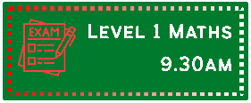  Math exams  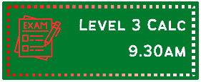  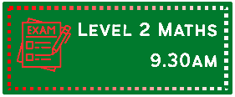  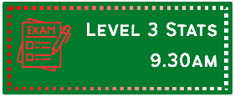 |  | English exams          
                      Science exams |  |       Commerce exams          
Social Sciences exams                       |  |                 Other exams











MISC

